Experiment 21: Logistic Regression Using Iris Dataset
data("iris")
set.seed(123)
index <- sample(1:nrow(iris), 0.8 * nrow(iris))
train <- iris[index, ]
test <- iris[-index, ]
model <- glm(
Species ~ Petal.Length + Petal.Width,
data = train,
family = binomial,
subset = Species != "virginica"
)
test_binary <- subset(test, Species != "virginica")
pred <- predict(model, newdata = test_binary, type = "response")
predicted <- ifelse(pred > 0.5, "versicolor", "setosa")
confusion <- table(
Predicted = predicted,
Actual = test_binary$Species
)
print(confusion)
accuracy <- mean(predicted == test_binary$Species) * 100
print(accuracy)
OUTPUT
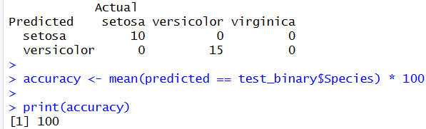

Experiment 22: If-Else and Arithmetic & Boolean Operators
num <- 5

if (num > 0) {
result <- "Positive"
} else if (num < 0) {
result <- "Negative"
} else {
result <- "Zero"
}

a <- 10
b <- 3

sum_val <- a + b
diff_val <- a - b
prod_val <- a * b
div_val <- a / b

bool1 <- (a > b)
bool2 <- (a == b)
bool3 <- (a != b)

print(result)
print(sum_val)
print(diff_val)
print(prod_val)
print(div_val)
print(bool1)
print(bool2)
print(bool3)
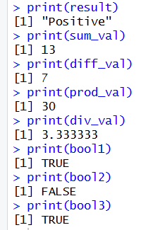

Experiment 23: For Loop – Printing Multiplication Table
num <- 5
for (i in 1:10) {
result <- num * i
cat(num, "*", i, "=", result, "\n")
}
total <- 0
for (i in 1:10) {
total <- total + i
}
print(total)
OUTPUT
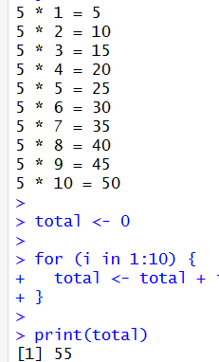
Experiment 24: While Loop – Sum of Digits
num <- 1234
sum <- 0
while (num > 0) {
digit <- num %% 10
sum <- sum + digit
num <- num %/% 10
}
print(sum)
OUTPUT

Experiment 25: Control Statements – break and next
for (i in 1:10) {
if (i == 3) {
next
}
if (i == 8) {
break
}
print(i)
}
OUTPUT
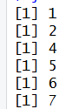

Experiment 26: Looping Over Lists
my_list <- list(a = 10, b = 20, c = 30)
for (item in my_list) {
print(item)
}
names_list <- names(my_list)
for (name in names_list) {
cat(name, "=", my_list[[name]], "\n")
}
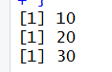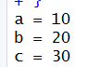
Experiment 27: Functions with Default Argument Values
add_numbers <- function(a, b = 10) {
result <- a + b
return(result)
}
print(add_numbers(5))
print(add_numbers(5, 20))
OUTPUT
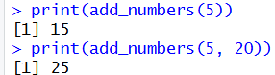

Experiment 28: Return Values and Explicit return()
square_number <- function(x) {
x * x
}
cube_number <- function(x) {
return(x * x * x)
}
print(square_number(4))
print(cube_number(3))
OUTPUT
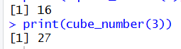
Experiment 29: Returning Multiple Values Using a List
calculate_stats <- function(x) {
result <- list(
sum = sum(x),
mean = mean(x),
max = max(x),
min = min(x)
)
return(result)
}
data <- c(10, 20, 30, 40)
stats <- calculate_stats(data)

print(stats)
OUTPUT
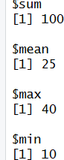
Experiment 3O: Functions Are Objects in R
my_function <- function(x) {
x + 1
}
print(class(my_function))
print(my_function(10))
another_function <- my_function
print(another_function(20))
OUTPUT
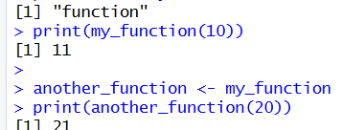

Experiment 31: Recursion – Factorial Program
factorial_fun <- function(n) {
if (n == 1) {
return(1)
} else {
return(n * factorial_fun(n - 1))
}
}
print(factorial_fun(5))
OUTPUT
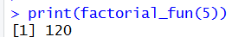
Experiment 32: Fibonacci Series Using Recursion
fibonacci <- function(n) {
if (n == 0) {
return(0)
} else if (n == 1) {
return(1)
} else {
return(fibonacci(n - 1) + fibonacci(n - 2))
}
}

n <- 10
cat("Fibonacci Series using Recursion:\n")
for (i in 0:(n - 1)) {
cat(fibonacci(i), " ")
}
cat("\n")
OUTPUT
